H.T No
Regulations:
A20

Sreenidhi Institute of Science and Technology
(An Autonomous Institution)
Code No:8HC10 Date: 20-Sept-2024 (AN)

B.Tech I-Year I- Semester External Examination, Sept-2024 (Supplementary)
LINEAR ALGEBRA AND CALCULAS (CSE,IT,ECM, CS, AIML, DS and IOT)

Time: 3 Hours Max.Marks:70

Note: a) No additional answer sheets will be provided.
b) All sub-parts of a question must be answered at one place only, otherwise it will not be valued.
c) Missing data can be assumed suitably.
Bloom's Cognitive Levels of Learning (BCLL)

Remember | L1 | Apply | L3 | Evaluate | L5
Understand | L2 | Analyze | L4 | Create | L6

Part - A Max.Marks:20

Answer all QUESTIONS.

 |  | BCLL | CO(s) | Marks
1 | Define Symmetric Matrix and Skew-Symmetric Matrix. | L1 | CO1 | [2M]
2 | Is the matrix 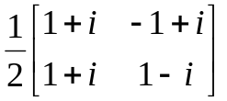 an unitary? | L3 | CO2 | [2M]
3 | Define Subspace. | L1 | CO3 | [2M]
4 | Define inner product space. | L1 | CO4 | [2M]
5 | State Rolle’s theorem | L3 | CO5 | [2M]
6 | Show that 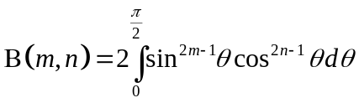 | L5 | CO6 | [2M]
7 | Find the value of k such that the rank of 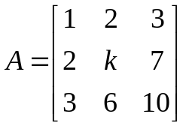is 2. | L3 | CO1 | [2M]
8 | Define basis for vector space. | L2 | CO3 | [2M]
9 | Evaluate 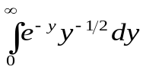 | L5 | CO5 | [2M]
10 | Define modal matrix and spectral matrix. | L1 | CO6 | [2M]

Part – B Max.Marks:50
ANSWER ANY FIVE QUESTIONS. EACH QUESTION CARRIES 10 MARKS.

 |  |  | BCLL | CO(s) | Marks
11. | a) | Find the rank of the matrix 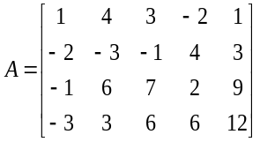 | L1 | CO1 | [5M]
 | b) | Show that 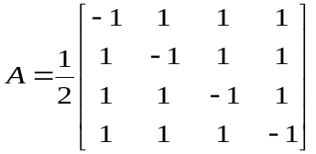 is orthogonal. | L3 | CO1 | [5M]
12. | a) | Show that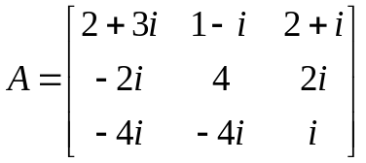is skew-Hermitian matrix. | L3 | CO2 | [4M]
 | b) | Find the Eigen values and Eigen vectors of the matrix 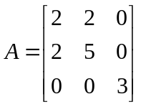 | L1 | CO2 | [6M]
13. | a) | Let. Determine S is linearly independent or dependent? | L5 | CO3 | [5M]
 | b) | Consider , then 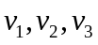form a basis for 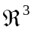 | L3 | CO3 | [5M]
14. | a) | In the inner product space with standard inner product, if set is  S={(1, 1, 0), (1, -1, 1), (-1, 1, 2)} is an orthogonal set. Then find  equivalent orthonormal set. | L3 | CO4 | [6M]
 | b) | Write the basic properties of inner product | L2 | CO4 | [4M]
15. | a) | Find the value of c of Cauchy’s mean value theorem for 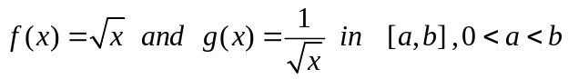 | L3 | CO5 | [5M]
 | b) | Prove that if 0 < a < 1, 0 < b < 1 and a < b, then 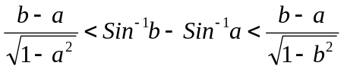and hence deduce that 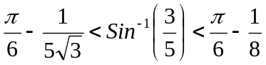 | L5 | CO5 | [5M]
16. | a) | Prove that 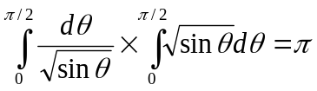 | L4 | CO6 | [5M]
 | b) | Find the volume of the tetrahedron bounded by the planes x=0, y=0, z=0  and 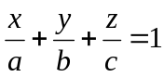 | L1 | CO6 | [5M]
17. | a) | Find whether the following equations are consistent or not, if so solve them x + y + 2z = 4, 2x – y + 3z = 9, 3x – y – z = 2. | L1 | CO1 | [5M]
 | b) | Verify Cayley-Hamilton theorem for 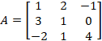 | L3 | CO2 | [5M]
18. | a) | Suppose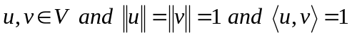. Then prove that | L5 | CO5 | [4M]
 | b) | Verify Rolle’s mean value theorem for the following 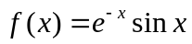 in [0, | L3 | CO6 | [3M]
 | c) | Show that 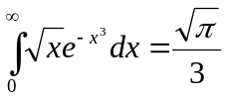 | L5 | CO6 | [3M]
-- 00 -- 00 –

